PRODUCT MANAGEMENT

1.1 Introduction
The objective of Product Management applet is to create products with Brand-Family-Machine-Model-Project in quest. Two types of Products can be created namely Drafts and Active products. New/Edit/Delete/save operations can be performed on products using Product management applet. Three ways exists for creating Products i.e. from Blank, template and using Import.

1.2 Application Overview

- In Quest Input Tool, applets will be available under workspace for creating products, documents, users, etc…
- Click on the Product Mgmt Applet.
Following screen appears.
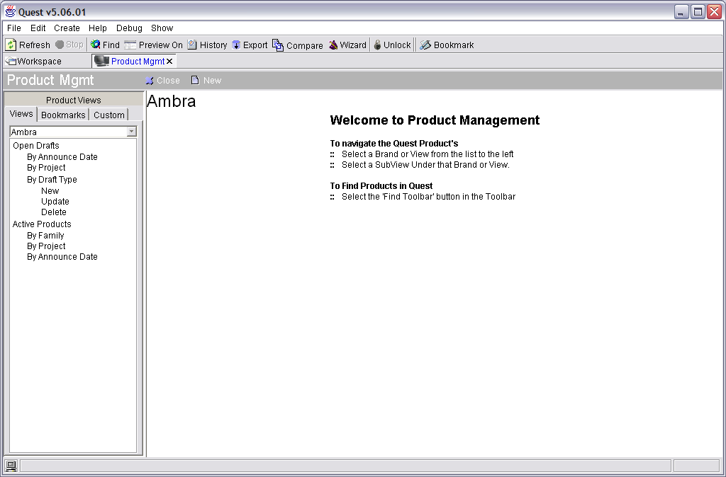

- On the left hand side, Under Product views all Brands available will be displayed to create products under that particular brand.
- Select a Brand from the left hand view and click on the NEW button to create a new Product.
Available Brands: Ambra, Misfits, Servers, Data Mapping, Cross Brand,
Aptiva, Intellistation, Monitors, Options, IBM PC, ThinkPad and WorkPad,
ThinkCentre, Netvista Thin Client, Netvista, Network station Thin Client,
System Management, Thinkvantage Technologies.
- Created Products will have two states
    - Draft State -> Not Yet Published
    - Active State ->Appear in website.
    - Drafts are stored in PRODRAFT SCHEMA and Active Products are stored in PRODUCT schema.
- Click on New Button to create new Product (Active / Draft). New Product will come under the Brand selected on the left hand side.
- There are three options provided to create a new Product. New Product from
    - Blank Product
    - Template
    - Import
Below Screen appears

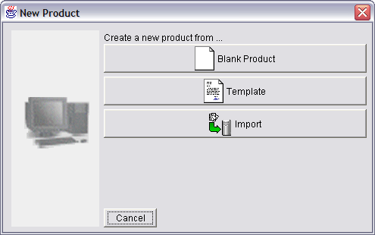

7.1 BLANK PRODUCT

7.1.1 New

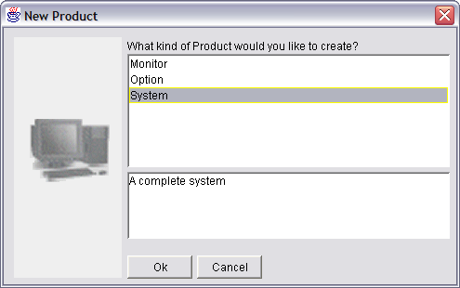

Kinds of Product:
    - Monitor - Visual Displays - create product for Brand – Monitors Only
    - Option - An Accessory, Peripheral etc. including Mice, Keyboards,
Network Adapters, Hard Drives, Memory...
Create Product for Brand – Options Only.
    - System – A complete system – Create Product for any Brand.
After selecting kind of project, click next – Product wizard and enter the
Products description.

    - Select the product information like Brand, Family, Machine, Project, Model
All the fields are mandatory
7.1.2.1 Select any Brand from the list
7.1.2.2 Families that come under brand will be selected and displayed.
7.1.2.3 Machine can be selected from the existing list or create new by clicking
on the New Link
7.1.2.4Project can be selected under the available list according to machine or
create new project. All models should come under any one of the
projects.
7.1.2.5Model should be NEW. After entering the model, Press ‘Enter’ to
check whether model already exists. If exists, change model.
Otherwise, proceed to save the product i.e. Product will be registered
as achi-NNN.
Machine – Four Characters
Model - Three Characters

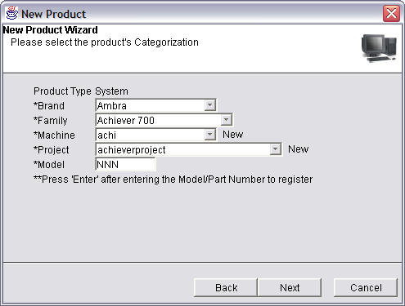

7.1.3Next select the product’s location or click on Worldwide to publish product all over the world
7.1.4Next select a Date Type. Product.typedate table holds the different types of dates that can be applied to a product.
Current data includes
Withdrawn
Announced
Deleted from XRef
Pre-Announced
GA Available
End of Service
End of Manufacturing
End of Marketing
End of Production
Ship Supported
First Ordered

Date Format : 02 Aug 2005 ( dd/mon/yyyy)
Based on the announced date given, it will be shown in site

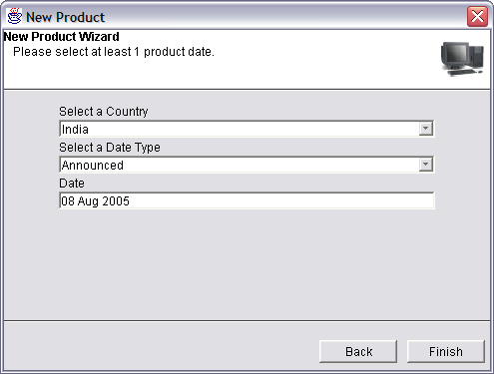

7.1.5After Clicking on Finish, it will open in edit mode so that any selected options in the wizard can be modified.

Available options in Edit Mode:
Mandatory: Brand, Family, Machine, Model, and Project

Other info:
* Offering
* Customer
* Warranty

Optional: Base model
End of life
Comments & Comment History
Input
Source
Base Model: This is the model from which the product was based off of. In IBM, There is always 1 single model that '20' different models are based off of. Changes to the base model include processor upgrades, hard drive
sizes, memory sizes etc.
Input: Who entered the data into the database for this product? An Author or PRODGEN, the OPICM Import.
Source: What is the source for the information. Free entered text
End of life: It indicates whether product is activated or deactivated. While creating the product, if checkbox for end of life is selected, then that product is in hidden state. It will not be displayed in site. In prodraft.product table, end of life field set to ‘N’ or ‘Y’.
Offering: Different types of offerings that can be applied to a product. An offering is something that IBM offers to sell to the customer.
Current data:
Default Offering
CTO Offering

7.1.6 Save: Product can be saved in four different ways
      - Save As Draft
      - Save As Template
      - Save As New Product
      - Cancel Draft
      - Publish

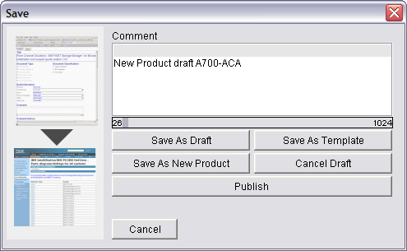

After editing there was two options save & close. Data will be stored in different
Tables/Schema based on different save options
7.1.6.1 Save As Draft
In Prodraft schema, data related to product will be stored in Prodraft.product, Prodraft.typecategory, Prodraft.category and Prodraft.typecatchild tables

Prodraft.product: This table is the heart of the eSupport Product Draft. Most data
relating to the product, including the Draft Product's Primary Key (PRODUCTIND) is
stored in this table. Other tables, which hold data for a product, include
PRODRAFT.CATEGORY, PRODRAFT.COUNTRY, PRODRAFT.DATES and
PRODRAFT.GEO. Document can never be associated to a draft product.

Prodraft.typecategory: This table is the heart of navigation for eSupport. It contains a parent/child view of all product data in the Quest Database. Read here for more information on this parent/child hierarchy.

Prodraft.Typecatchild: This table holds the complete hierarchy from one child to the child's grandparent. Basically, it holds all parents that a particular TypeCategory has. For example, a model listed in this table would be listed with its machine, project, family and brand. A project in this table would have it's family and brand listed.

71.6.2 Save As Template
Created product can be saved as a template. Name should be provided to the template so that appropriate template can be selected while creating the product.
Template means using the existing one new product can be created with the
appropriate changes needed.

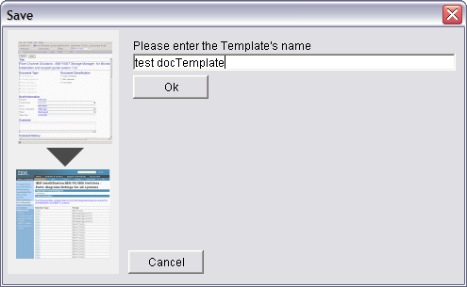

Template data is also stored in prodraft.product with all fields same as for creating a
draft except the template filed set to ‘Y’. Data will be stored in typecategory,
typecatchild and category tables.
E.g.: All templates created by any user (NARAPPA) can be retrieved by

Query: SELECT PRODUCTIND, PRODNUM, DESCRIPTION, CREATEDON,
CREATEDBY, LASTTOUCHEDBY, LASTTOUCHEDON FROM PRODRAFT.PRODUCT
WHERE LASTTOUCHEDBY = 'NARAPPA' AND TEMPLATE = 'Y'

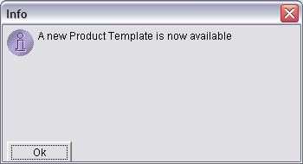

7.1.6.3Save as New Product
While saving as new product, it will display following dialog box Displayed to save the draft product information in the product editor or not. If yes, we will be able to see the selected brand, family, machine, model and Project and that can be edited or else entirely new information should be provided.

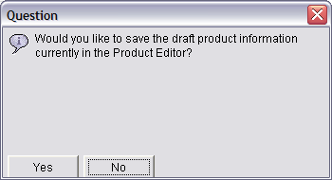

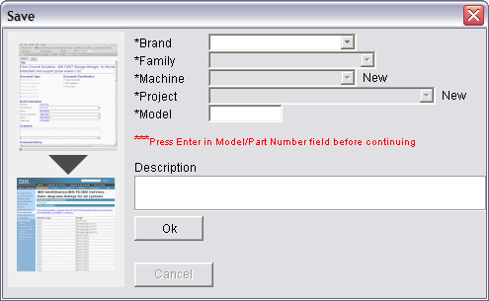

Model should be different in any case from the previously selected list of brand, family, machine, model and project.
- If model is same, the following screen is displayed to re-enter the model/partnum.
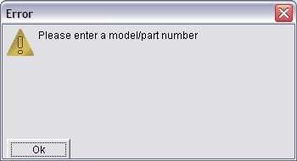

- If model is different, then New product created box appears as displayed below

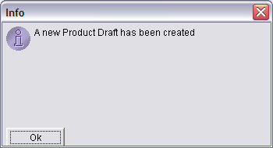

E.g. Say product with 6737-HHH, save it as new product as MMM. After that save as new product will create entries in table prodraft.product with basemodel as HHH, prodnum as 6737-MMM and Typeproductind as 3

7.1.6.4 Publish
Published product will be displayed in site. It will be stored as active product and will be stored in Product schema. ExistingProdInd of the product draft in Prodraft.product will become the productind of active product.

ExistingProdInd
The Existing Product Indicator is the Product Primary Key for this Draft's
Published Product. This indicator does not need to be in the PRODRAFT.PRODUCT table.
For example, if this draft represents a Draft for a new Product, then the Existing Product Indicator might be a non-zero value, but it also is not in the PRODRAFT.PRODUCT table until the draft is published.

Startdate & Stopdate

Start date is the date that the draft was started on. This date defaults
to the date that this record was created. Stop date is the date that this draft was stopped on. Once this product draft has a stop date in the Quest database, the draft is considered closed. It is published. When same draft, which is published, is edited and saved then, it has same existingdocind as before but, different typecatind. When you publish this, updated information will be stored in the Product.product table.

Any product is current a misfit product. A Misfit product draft is created when ProdGen cannot find a Country/Geo or Brand/Family mapping in Quest.

Product. product:
This table is the heart of the eSupport Product. Most data relating to the product, including the Product's Primary Key (PRODUCTIND) is stored in this table. Other tables, which hold data for a product, include PRODUCT.CATEGORY, PRODUCT.COUNTRY, PRODUCT.DATES, PRODUCT.GEO and PRODUCT.XREF. Documents are associated to products in the TIGRIS.CATEGORY table.

7.1.6.5 Cancel draft:
Canceling a draft means removing the corresponding entries from the prodraft.category, prodraft.typecategory and prodraft.typecatchild tables. While creating a new product draft, if there are new machine, model, project entries. Then, canceling the draft will do following changes to the prodraft schema.

In Typecategory -> Model and Project entries are deleted.
In Typecatchild -> Model entry is deleted.
In Category -> Model, Project, Machine entries are deleted.

Canceling a draft can be done in two ways:
- After creating a product while saving, an option is provided to cancel the product.

- After creating a product save the product as draft or publish. Then, view the product draft by using product views provided on the left hand side of the product management applet. On top of right hand side, Cancel draft option is provided.

7.2 TEMPLATE

Creating a template can be done in three ways

  - Create a new product draft and save. While saving, select option “Save as Template”. Provide a name and draft will be saved as template.
  - Open an existing template and edit the template. Then, save it as template.
  - Open an existing draft either published/draft, “save as template”

Any Template can be identified by a field (template) that is set to ‘Y’ in prodraft.product table.
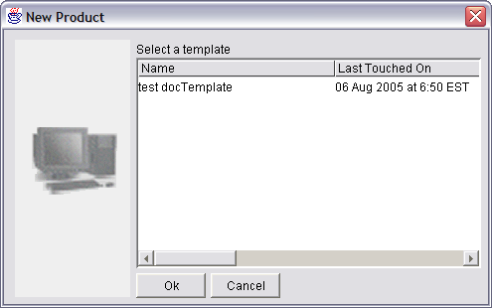

While creating a product as draft or publish or new product, there are restrictions like Brand, Family, Model, Machine and project entries all are mandatory. For creating a template, there are no restrictions.

Eg: 1) Select a brand, save as template accepts.
2) IF Brand, Family, Machine are selected and saved other than template following error is displayed

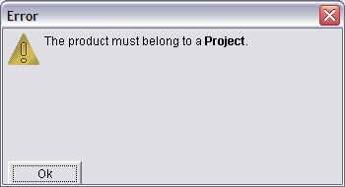

7.3IMPORT

Using IMPORT, New products can be created

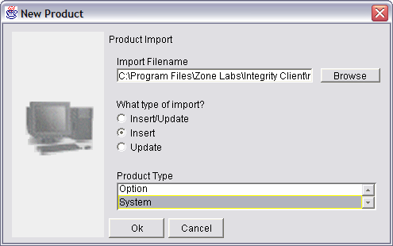
Import Filename
Three types of import: Insert/Update, Insert and Update
Three types of product Type: monitor, option, and system

PCD/Lenovo will create a list of products in a sheet with all details. It will be in .csv format. Each row in the sheet will have one-product details. This batch imports product information from delimited file. The file contains information about products to insert, update or insert/update.

Following parameters:
Parameter Description Example
----------------- ------------------------------------- --------
/INSERT Only tries to insert each product /INSERT
/UPDATE Only tries to update each product /UPDATE
/INSERT_UPDATE Tries to update, then insert /INSERT_UPDATE
/OPTIONSONLY Only tries to process Options /OPTIONS
/SYSTEMSONLY Only tries to process Systems /SYSTEMS
/MONITORSONLY Only tries to process Monitors /MONITORS
/FILE: The Delimited file to load and process /FILE: MYCSVFILE.TXT

This batch expects the delimited file to contain rows where each row in the
file represents a product. The rows should be setup are specified below for
Systems:

Field Description
-------------- ------------------
1 Brand Name
2 Family Name
3 Product Number
4 Machine Type
5 Model
6 Locale
7 Project Name
8 Comments
9 Warranty
10 Quest Description
11 Offering
12 Customer Name

Columns 1 - 10 are required

First it read the CSV File, and pulls out all of the rows. Determines whether or not the file has been completely parsed. Hold each row in each product String. Each row will be added to the string. After Parsing Completes, a dialog box is displayed to press the Commit button to commit these Products. It also makes sure that the countries are valid, and make sure the date is valid and properly formatted.
Committing will insert or update the imported product information in the database. It also checks to see if the product we want to import is new. It will insert a new product. The Product Draft could not be updated, if a Product with Part Number already exists for OPTIONSONLY and also a Product with PRODUCT NUMBER for SYSTEM.

Flowcharts:

Product Management applet - User selects type of Product
BLANK PRODUCT
IMPORT
TEMPLATE
USER SELECTS PRODUCT TYPE MONITORS, OPTION, SYSTEM
USER SELECTS BRAND, FAMILY
SELECTS EXISTING MACHINE
CREATES NEW MACHINE
CREATES NEW PROJECT
SELECTS EXISTING PROJECT
ALREADY EXISTS (Y/N)
YES
NO
ALREADY EXISTS (Y/N)
YES
NO
CREATES NEW PROJECT
SELECTS EXISTING PROJECT
CREATE MODEL
ALREADY EXISTS (Y/N)
YES
NO
SAVE AS DRAFT OR PUBLISH OR TEMPLATE
PARSES AND COMMITS PRODUCT
SELECT EXISTING TEMPLATE & EDIT
SAVE AS DRAFT OR PUBLISH PRODUCT
IMPORT FILE CONTAINING PRODUCT INFORMATION
ALL 12 FIELDS IN FILE SELECTED (Y OR N)
Mandatory Fields Brand, Family, Product number, machine, model, locale, project, comments, warranty, offering, customer name

